**Machine Problem 3: Python**

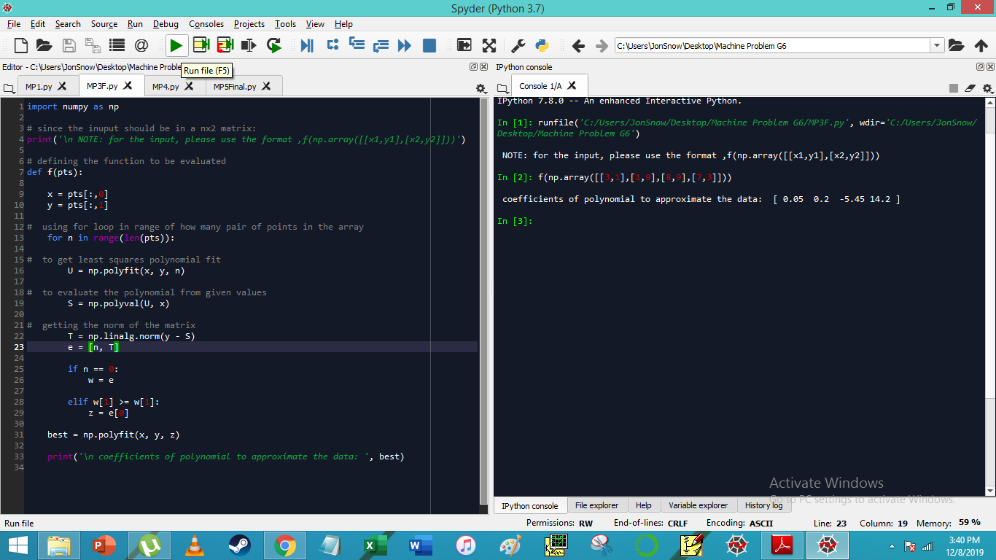

Output:

